Date 26/06/2026 LINUX VIDEO- 02 TASK
1 Adduser = to add a new user
2 Passwd =to set a password to new user
3 Pwd = for check present directory
4 Cd = for change directory
5 Mkdir =to create a new directory
6 Touch = for create a new files
7 Cat = to get the information of file

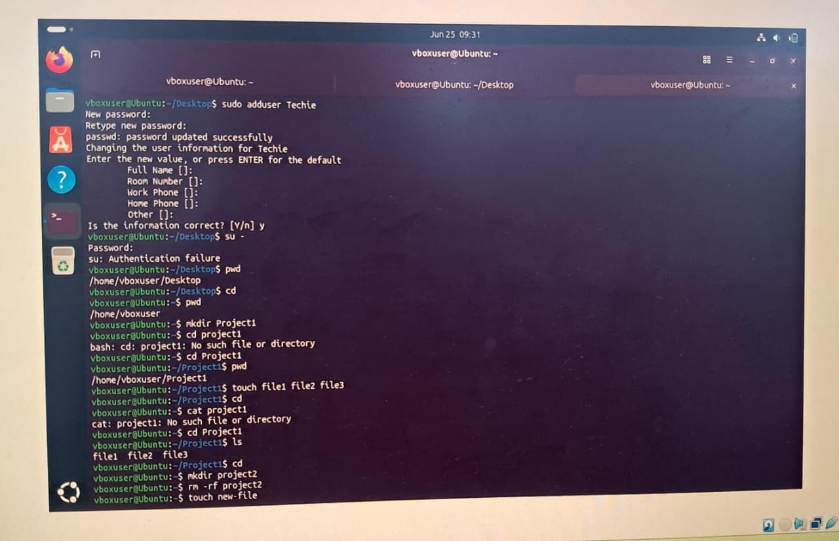

8 Touch = to create a new file
9 Cat = it shows inside the information of file
10 Cp = it copy the data from one file to another file
11 LL = it shows the list of files nd its informaions

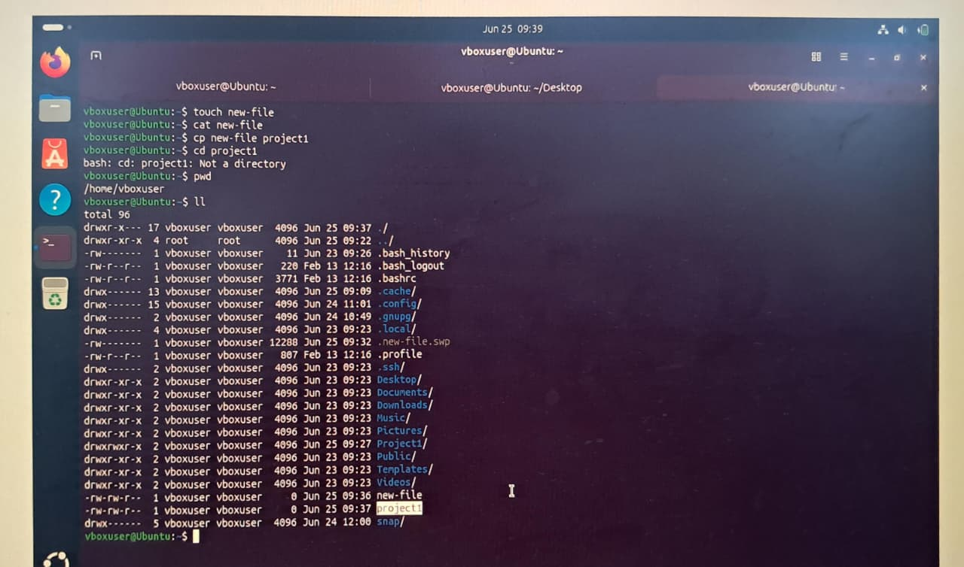

12 Ls = it shows the short list of files
13 Touch = used for create a new files
14 Mv = is used for rename the file
15 Rm -rf = is used for delete the file
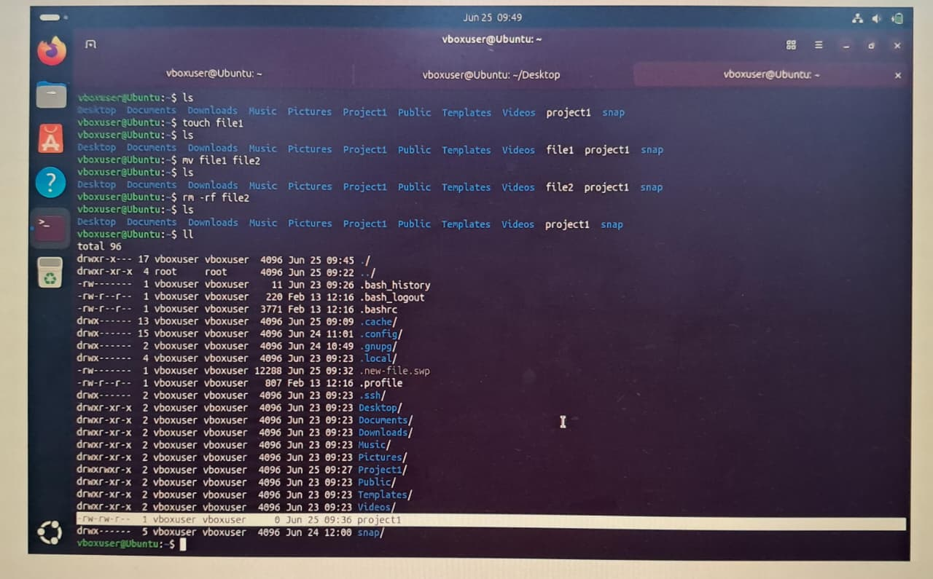
16 chomd 777 = to provide the full access to file for practise purpose
17 LL = for long list the files
18 Date = to see the todays date and time
19 Ps -ef = to display all currently running processes
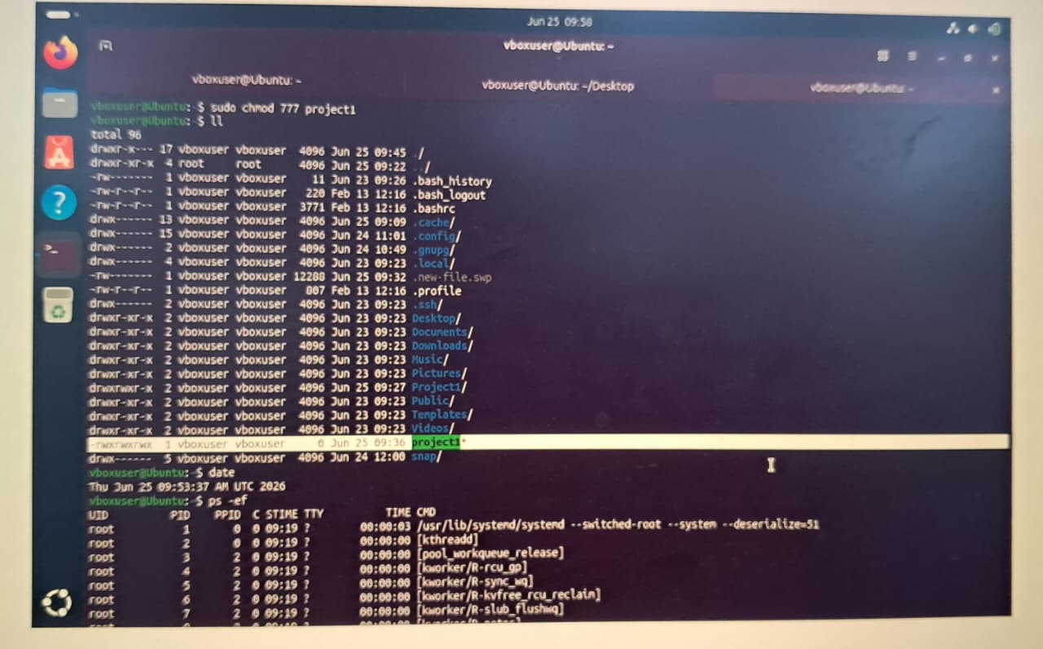

20 Sudo apt update = to install the updated package
21 Sudo apt install git -y = to install the git software
